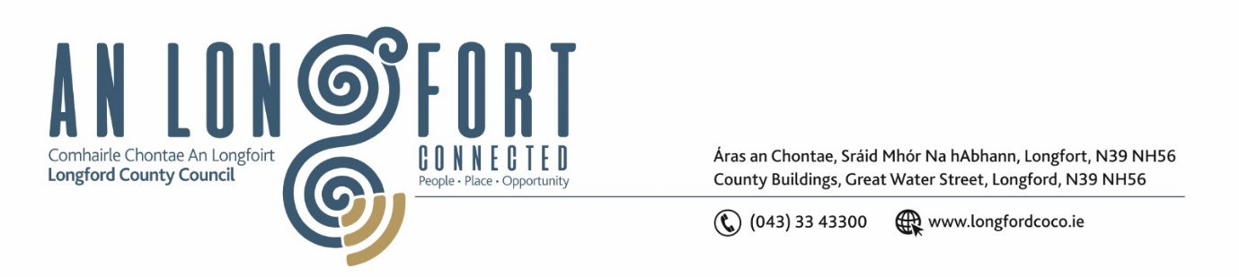**LONGFORD MUNICIPAL DISTRICT**

**Minutes of Meeting of Longford Municipal District**

**held in the Council Chamber Aras an Chontae and via MS Teams**

**on Wednesday, 21 February 2024 at 4pm**

**CATHAOIRLEACH**: Councillor Martin Monaghan

**MEMBERS PRESENT**: Councillors – Uruemu Adejinmi, John Browne, Seamus Butler, Peggy Nolan, Gerry Warnock, Gerry Hagan

**IN ATTENDANCE**: Mr. John Brannigan, Director of Services

Mr. Eamon Bennett, Senior Executive Engineer

Ms. Lorraine McKee, Administrative Officer

**MEETINGS**

**ADMINISTRATOR:**  Ms. Claire McNabola

**APOLOGIES:**  None

1. **ADOPTION OF MINUTES – circulated**
2. On the proposal of Councillor John Browne seconded by Councillor Peggy Nolan it was unanimously agreed to adopt Minutes of Meeting of Longford Municipal District held on Wednesday 24 January 2023, as circulated.
3. On the proposal of Councillor John Browne seconded by Councillor Peggy Nolan it was unanimously agreed to adopt Minutes of Committee Meeting of Longford Municipal District held on Wednesday 24 January 2024, as circulated.
4. **MATTERS ARISING FROM MINUTES**

None.

1. **DECLARATION OF INTEREST BY MEMBERS**

None.

1. **MANAGEMENT REPORT - circulated**

The Management Report, as circulated, was noted.

Members raised matters in relation to:

* Grass Cutting in St. Emer’s
* Regulations on Headstones in Ballymccormack Cemetery
* Footpaths at Lidl on old Dublin Road
* Yellow Lines on Pearse Road

The Members unanimously congratulated everyone involved in the opening of the Skatepark and Cllr Nolan was thanked for her dedicated to the project over the years.

1. **COMMUNITY GRANT SUPPORT SCHEME 2024**

Lorraine McKee briefed the members on the 2024 Community Grant Support Scheme:

* The funds available under the Community Grant Support Scheme and the fact that the scheme was completely over subscribed
* The number of applications received and funding requested by individual groups
* Some new groups applied for the first time

On the proposal of Councillor Seamus Butler, seconded by Councillor Uruemu Adejinmi the members unanimously agreed and approved the Community Grants support scheme for the amount of €95,119.42 as per attachment

1. **CONSIDERATION OF DRAFT MUNICIPAL DISTRICT REPORT FOR INCLUSION IN LONGFORD COUNTY COUNCIL 2023 ANNUAL REPORT – as circulated**

On the proposal of Councillor Gerry Hagan, seconded by Councillor Martin Monaghan, the members agreed to adopt the Draft Municipal District Report for inclusion in the Longford County Council 2023 Annual Report.

1. **TOWN TWINNING REPORT – as circulated**

Noted

1. **NOTICES OF MOTION, SUBMITTD BY COUNCILLORS, AS LISTED HEREUNDER:**

**The following notice of motion was proposed by Councillor Uruemu Adejinmi and seconded by Councillor Seamus Butler**

1. I call on Longford County Council to implement a Low Cost Safety Scheme to facilitate safe crossing of pedestrians in front of the Cinema and the apartment buildings across the road.

**Response**

We will refer this to road design to carry out a review of safety on the Church St Lower Main St. section of the R -198. I wish to point out that sight distance is an issue in relation to a pedestrian crossing at this location. If road design determine that a pedestrian crossing is suitable at this location they will make a submission to the Department for funding a low cost safety scheme in 2025.

**Other Matters**

**Consideration of Nominations to the Biodiversity Working Group**

On the proposal of Councillor Seamus Butler, seconded by Councillor Gerry Warnock, the members agreed to nominate Councillor Uruemu Adejinmi to the Biodiversity Working Group

This concluded the business of the meeting.

**Signed: ____________________**

**Claire McNabola,**

**Meetings Administrator.**

**Confirmed and adopted at Longford Municipal District Meeting held on the 27 March 2024.**

**Signed: _______________**

**Cathaoirleach**